# IN712 Web 3 Practical 2.2 – Introduction to JavaScript

Solve each of the following exercises using JavaScript, HTML and CSS, as required. All of the required concepts have been covered in lecture, but you will need to research some of the implementation details.

1. Build a web page containing a button, a text box and a div for displaying output. The user types a number into the text box, then clicks the button. In the div they see the value produced by counting backwards from the input value to 1. The display text should be <h3>. An example is:

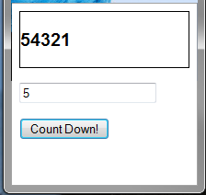

1. In lecture, we used the HTML element property ‘innerHTML’. Another useful element property is ‘style’. An element’s style is a collection of all its CSS properties. You can apply CSS rules dynamically to the element by modifying the style property. For example, assume you have a button on your HTML page whose ID is “btnCSSDemo”. If you arrange for the following lines of code to be executed (in the onload event, in a button click handler, etc.), the button text will increase to 50px (and the button will grow to fit).

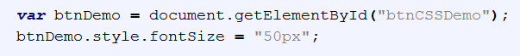

* 1. Construct a web page that contains a list. Add a button and JavaScript code so that clicking the button puts a border around the list and sets its background to orange.

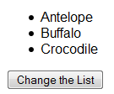 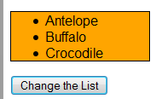

Before After

* 1. It is not actually necessary to change each CSS property separately by updating the element’s ‘style’. You can also change several properties at once by assigning a ***CSS class*** to the element. Repeat exercise 2a by creating a CSS class with multiple style rules and assigning it to the list in one statement. You will need to add a CSS file to your web site (if you don’t already have one), define the class, and figure out the correct syntax for assigning the class in the JavaScript.

1. Build a web page containing a button and a text box. The user types a string into the text box, and then clicks the button. They receive an alert (or write to a div, if you prefer) displaying the ***number of vowels*** (a, e, i, o & u) in the string. Encapsulate the counting of the vowels into a function, and call that function when the button is clicked, passing in the contents of the text box. Remembering that you must count both uppercase and lowercase vowels, can you keep your if-statement to only five comparisons? (Hint: Look at the methods exposed by the JavaScript string class.)
2. While images are an important part of web pages, in some situations you might want to not display all the images on a page. For example, if your user is accessing the page from a phone with a slow internet connection, or if your user is running a TTS (text to speech) converter, it is better to display a text alternative. In this exercise you will build a page that allows the user to toggle between displaying an image and displaying just the file name. An example is shown below:

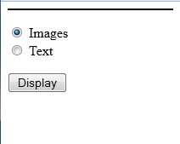 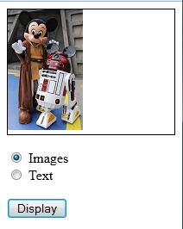 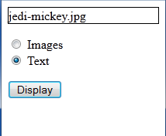

Page Open On Click – Images Selected On Click – Text Selected

This behaviour can be easily achieved by using functions as objects, as shown in class. To make this work you need three methods: one to show the image, one to show the text, and one to decide which function should be used and return an instance of the chosen function. That third function is bound to the button’s click event. The code for the deciding function and the binding of the click event from my solution is shown below, if you’d like to see them.

Build the web page as described.

